Tyler Butler

11/15/18

IT Analysis

Final Project

**Milestone #1:**

1. Using information from chapter 8 and previous information from the running case study paragraphs over the previous chapters, list at least five domain model classes that form the core functionality of the system.

* Patient
* Healthcare provider
* Monitoring
* Messaging
* DataInfo
* Cellphone

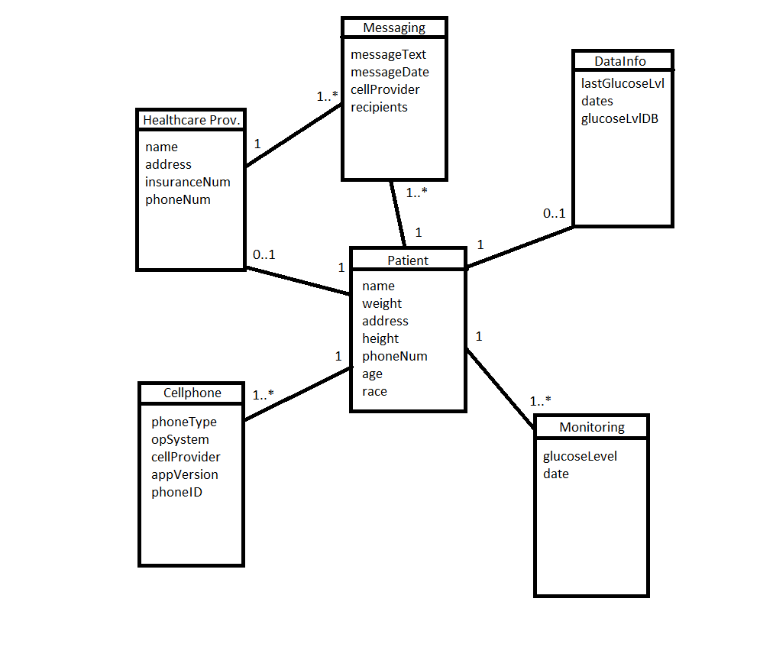

2. List at least five tables corresponding to the domain model classes above. Include the following information for each of the tables: primary key, foreign keys to other tables, and other attributes that you think is needed to characterize the class. Also include whether or not the table is in third normal form or not - and why.

|  |  |  |  |  |  |  |
| --- | --- | --- | --- | --- | --- | --- |
| Patient | | | | | | |
| (PK)phoneNum | Name | Weight | Address | Height | Age | Race |

|  |  |  |  |  |
| --- | --- | --- | --- | --- |
| Messaging | | | | |
| (PK)recipientID | (FK)phoneNum | messageText | messageDate | cellProvider |

|  |  |  |  |  |
| --- | --- | --- | --- | --- |
| Healthcare Provider | | | | |
| (PK)providerID | (FK)phoneNum | Name | Address | insuranceNum |

|  |  |  |  |  |  |
| --- | --- | --- | --- | --- | --- |
| CellPhone | | | | | |
| (PK)phoneID | (FK)phoneNum | phoneType | opSystem | cellProvider | appVersion |

|  |  |  |  |  |
| --- | --- | --- | --- | --- |
| Datainfo | | | | |
| (PK)glucodeID | (FK)phoneNum | lastGlucoseLvl | Dates | glucoseLvlDB |

|  |  |  |  |
| --- | --- | --- | --- |
| Monitoring | | | |
| (PK)monitorID | (FK)phoneNum | glucoseLvl | Date |

1. Patient: This table is in third normal form since all the non-key attributes are not functionally dependent upon each other.
2. Messaging: This table is in third normal form since all the non-key attributes are not functionally dependent upon each other.
3. Healthcare Provider: This table is in third normal form since all the non-key attributes are not functionally dependent upon each other.
4. Cellphone: This table is not in third normal form since this table is not in second normal form and is not dependent on the primary key
5. DataInfo: This table is in third normal form since all the non-key attributes are not functionally dependent upon each other.
6. Monitoring: This table is in third normal form since all the non-key attributes are not functionally dependent upon each other.